Instruction for Preparing Abstracts (14 point centered, bold)
K. Tsuji^{A}, T. Yagi^{B} (11 point centered)
^{A} Dept. of Physics, Keio Univ. 3-14-1, Kohoku, Yokohama, 223-8522, Japan
^{B} ISSP, Univ. of Tokyo, Kashiwanoha, Chiba, 277-8581, Japan

- Introduction
The abstract should be written in English using the Times New Roman font (14 point for the Title and 11 point for the text), and should be single spaced. In the book of abstracts, papers will be printed reduced by 88%. The document (including title, authors, affiliation, postal address, figures and references) must be fitted within one page with a top margin of 30 mm and a bottom margin of 25 mm. The main text consists of two columns with 81 mm wide, spaced 8 mm apart.

Table 1. Topics of AIRAPT-22
T01 | Structure and phase transition
T02 | New developments using neutron and synchrotron sources
T03 | Electrical and magnetic properties
T04 | Optical and acoustic properties
T05 | Molecular and organic solids
T06 | Liquid and amorphous materials
T07 | Water and ices
T08 | Thermophysical properties of fluids
T09 | Supercritical fluids
T10 | Geophysical and planetary science
T11 | Computational materials science
T12 | Chemical reaction and kinetics
T13 | Synthesis of new organic and inorganic materials
T14 | Superhard materials
T15 | Superconducting and novel materials
T16 | Dynamic pressure and shock wave
T17 | Bioscience an food technology
T18 | Hot and cold isostatic pressing process
T19 | Apparatus and instrumentation
T20 | High pressure scale

The title, author(s) and affiliation(s) should be centered. Section titles should start without indentation. Leave a space of one line between the affiliation(s) and the first section title, and one line between text and figures (tables etc.) or captions. Underline the name of the author who will present the paper. Please write the e-mail address of the corresponding author at the end of the references (*).
One participant can submit only one paper except the invited talk and the paper for symposium.

- Submission
The author should send the author information and the abstract pdf file to the conference secretariat. The author should select the first and the second suitable topics numbers from the list. Next, the author should choose the preference of the presentation; oral presentation, poster presentation or either. The decision will be made by the Program Committee.
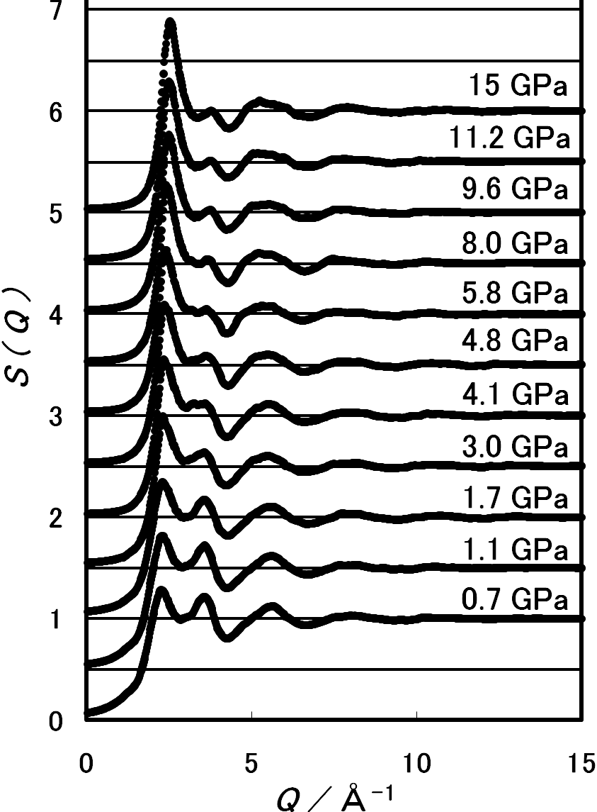
Figure 1. Figures and Tables should be included in the main text. Monochromatic abstract will be printed in the book of abstracts.

References
[1] A. Odaiba, Phys. Rev. Lett., 85, 12345 (2001)
[2] B. Tokyo, C. Chiba, J. Phys. Soc. Japan, 34, 567 (2008).
[3] Proc. AIRAPT 21 Conf. (2007) p. 789.
* airapt22@prime-intl.co.jp (e-mail address of the corresponding author)

